[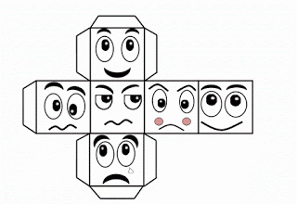](http://4.bp.blogspot.com/-cQXASC_6XYA/UW-8OAabe1I/AAAAAAAALyQ/Ov5NazgJ5Go/s1600/%CE%96%CE%91%CE%A1%CE%99+%CE%A3%CE%A5%CE%9D%CE%91%CE%99%CE%A3%CE%98%CE%97%CE%9C%CE%91%CE%A4%CE%A9%CE%9D.gif)